**Assistive System for Patients with Parkinson's**

**Aim:**

Technology to help working people the challenge has improved in recent decades. With modern technology, people with Parkinson's disease can, with machine on their wrist, able to draw pictures. Human organs lost due to accidents can be replaced with bionic organs and with the help of Smartphones, blind people can clearly be informed of what kind of object is appearing in the past there. These are just a few examples of how technology can be made reduce the daily lives of well-to-do people. The purpose of this concept is to analyze how the Arduino microcontroller can be used to help people with disabilities motor skills during their meal. Example of a stabilizing spoon is designed to work under real conditions and is intended to be human helpers who need help during their meal. To make this happen, a sensor with gyroscopes is attached with accelerometers it was used to indicate direction the device handle was tilted, and how fast its position was changed. Two servo motors were installed by joining together to establish a two-tier system of freedom. With this setup, the spoon was intended to keep its spoon bowl standing horizontally. Spoon test results showed promising performance to some extent.

**Hardware & Software Requirements:**

1. STM32L151 (STMicroelectronics) microcontroller.
2. MARG sensor
3. HC-05 Bluetooth module
4. STNS01 device
5. Spoon

**Project Flow:**

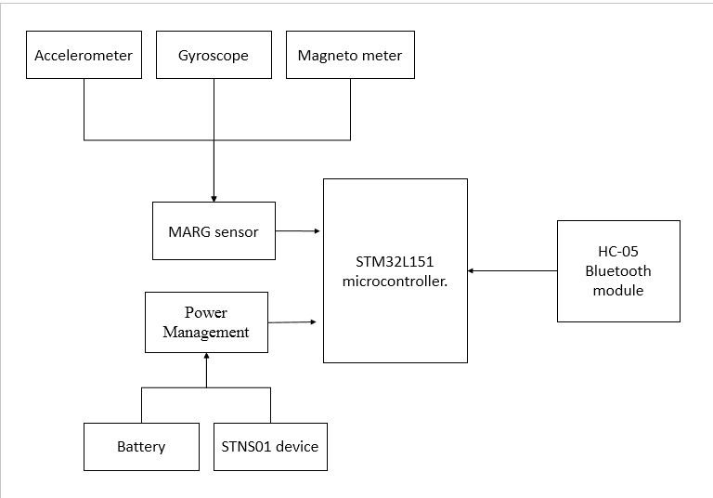

Spoon

**Proposed System**

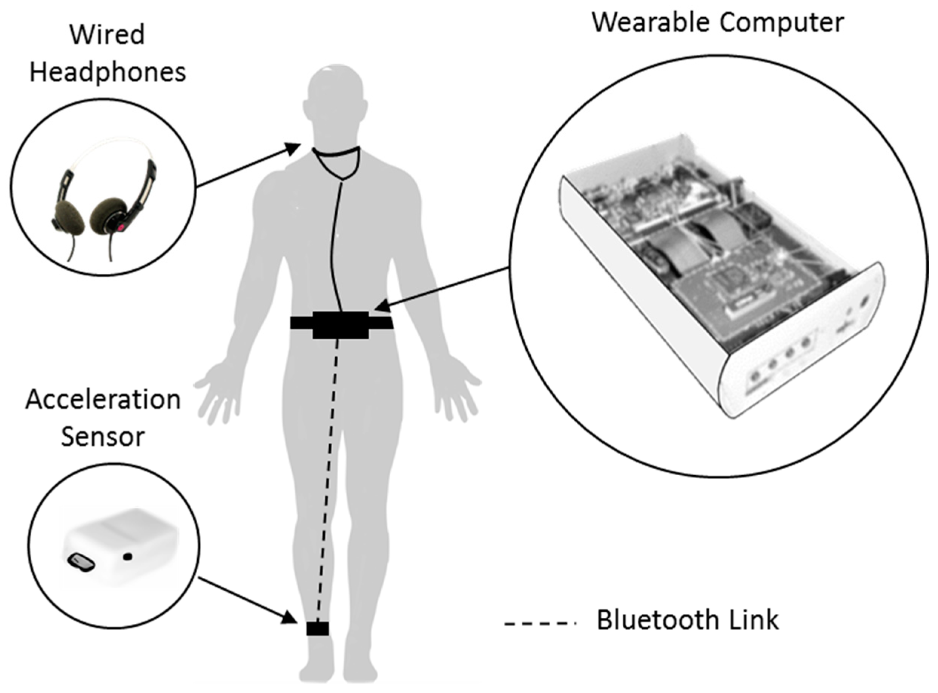

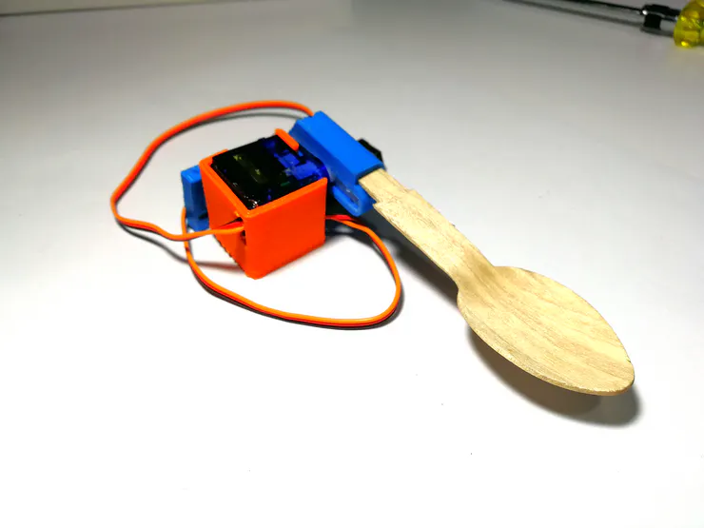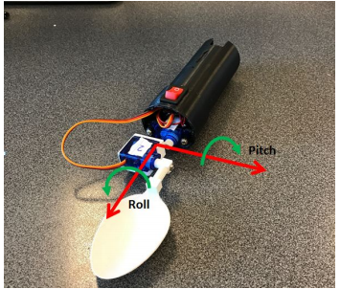

**Stake holders:**

The first main stock holders are the patients suffering from Parkinson as they can access it in their everyday life and they can happily eat anything with this modified spoon.

Then comes the commercials like the hospitals, Caretakers, family members, etc. they need the most in order to distribute these consumers or so called relatable members we can also call them “distributors”.

Last but not the least, comes the industrialist where they develop and upgrade the device specify or give accurate data on the symptoms of the diseases.

Finally the researchers & their team would examine all these in order to make a different approach to the consumers so that it can help in their research and come out of the box to make it easy and better than before.